**Emerald City – City Planning & Proposal Project**

**Essential Question measured by the transfer task:**

* What physical and human features make a place culturally unique?

|  |  |
| --- | --- |
| Prior Knowledge | In this unit you have examined the idea of place. You have learned to identify important human and physical features of a site. You have learned how the geographic situation affects the lives of people in the place. You know that culture affects the way people build and change their neighborhoods, towns and cities. |
| Problem/Role | You are a city planner (see Appendix 1). Your company would like to get the job of planning a modern city called “Emerald City.” Your job will be to help prepare a plan for the new city that will meet the needs of the residents. If your plan is selected, your company will continue to work on this project until the city is finished. Four sites for the residents to choose from have been selected (Appendix 3). |
| Perspective | The 50,000 people who will be living and working in Emerald City are committed to living a “green” way of life. They value technology as a way of making their life more convenient and reducing their impact on the environment. Emerald City residents like to spend a lot of time outdoors. They enjoy beautiful scenery and green space where they can exercise and gather for social and sports events.  Here are their requests:   1. The city should look and feel modern and tech-friendly. 2. The city should have clean, unpolluted air. 3. Most energy should come from wind power, hydroelectric power, or solar power. 4. There should be plenty of room for outdoor activities and sports. |
| Product | You will prepare a presentation for the bid opening. Each team will get only 3 minutes to explain their plan. Work together to make the most of the time allowed persuading the Emerald City Planner Search Committee that you have the best plan.  Use Appendix 2 to evaluations of the geographic site, situation, and cultural needs and perspectives of the residents. |
| Criteria for an Exemplary Response | To be judged excellent, you oral presentation will:   1. Include a clear concise description or “vision” of Emerald City, the place of the future. 2. Explain how you have selected the best spot for the city from the four choices offered. 3. Explain how your design accomplishes the goals of the new residents. |

j0205462Green Cities

Transfer Task

Appendix 1

**Working as a City Planner**

**What does a city planner do?**

City planners help design cities. Guided by the needs and wants of the residents, a city planner decides some important things about the city. For example, he or she might plan how tall the buildings should be, how wide the streets should be, and the street pattern. Even the number of street signs, and the designs bus stops, lampposts and trash cans go into the plan for the city. Every building must be designed with careful thought. How will people get power and water? How can homes and apartments be located close to public transportation? Aesthetic design, or how things look, is something else the planner must think about. The designer wants the city to be a place where people feel comfortable. To make sure the plan is practical and also pleasing to the people who will live there, a city planner must be creative.

**How does a city planner get the job done?**

The planner begins by surveying the possible physical sites to select the right one. Then he studies the people who will live and work there. Demographic, economic, and environmental studies must be completed to assess the needs of the community. The planner also asks people for their opinions. When all the information is gathered, a planner creates maps and designs. People can look at these general plans and suggest changes. Then the city planner works with architects to plan for the construction of bridges, radio and telephone towers, and other infrastructure such as roads.

Adapted Text - <http://www.princetonreview.com/Careers.aspx?cid=162>

Green Cities

Transfer Task

Appendix 2 - Evaluating Site and Situation

Use this form to evaluate each of the four land parcels that are possible building sites for Emerald City.   You will need to use a separate form for each parcel.

|  |  |  |  |  |
| --- | --- | --- | --- | --- |
| **Parcel #** | **Physical Characteristics** | **Can be used**  **“as is”** | **Must be changed** | **Problems or Notes** |
|  | Land and soil conditions |  |  |  |
|  | Climate |  |  |  |
|  | Natural resources |  |  |  |
|  | Outdoor space and  Scenery |  |  |  |
|  | | | | |

Student reflection:

Which parcel would be your personal choice for a place to live? Explain your answer.

___________________________________

**_______________________________________________________________**

**_______________________________________________________________**

Green Cities

Transfer Task

Appendix 2 - Evaluating Site and Situation

**Evaluating the Human Characteristics of the Site**

Now read below the information you have been given about the people who want to move to Emerald City.

The 50,000 people who will be living and working in Emerald City are committed to living a “green” way of life. They value technology as a way of making their life more convenient and reducing their impact on the environment. Emerald City residents like to spend a lot of time outdoors. They enjoy beautiful scenery and green space where they can exercise and gather for social and sports events.

Here are their requests:

* The city should look and feel modern and up-to-date.
* The city should have clean, unpolluted air.
* Most energy should come from wind power, hydroelectric power, or solar power.
* There should be plenty of room for outdoor activities and sports.

Use the graphic organizer below to evaluate the human characteristics of the site. Some facts have been added for you to get you started.

|  |  |  |  |
| --- | --- | --- | --- |
| **HUMAN FEATURES** | Facts from the reading | What facilities should be included? | Research needed |
| Facts about the people | 50,000 residents | Homes for 50,000 people | What age groups will be the largest? |
| Cultural values of the people |  |  |  |
| Activities of the people |  |  |  |

Green Cities

Transfer Task

Appendix 2 - Evaluating Site and Situation

The **geographic situation** of Emerald City will be important, too. As a planner you should know three facts.

* On the other side of the mountains is a large desert. Few people live there.
* There are six coastal cities to the north, or to the right, of Land Parcel 4. All of these cities are factory towns with lumber mills and refineries.
* The winds in this area usually blow from west to east.

How might these facts affect your choice of the best spot for Emerald City? Explain your answer with an example.

**________________________________________________________________**

**________________________________________________________________**

**________________________________________________________________**

Now that you have completed your evaluation of the physical and human aspects of the **geographic site**, and you have also considered the **geographic situation,** it is time to make a decision where to build the city and begin the preliminary plan.

I choose Land Parcel ___________.

Part II - Planning Emerald City

Use the sketch of the land parcel you selected, your physical and human site evaluations, and your thoughts about the geographic situation to plan Emerald City.

Combine all your ideas in a map or graphic. Be sure to label the important features.

Remember you will be presenting your ideas to the search committee. While you may spend many hours working on the plan, you will have only three minutes to get your ideas across.

Green Cities

Transfer Task Potential Sites

Appendix 3

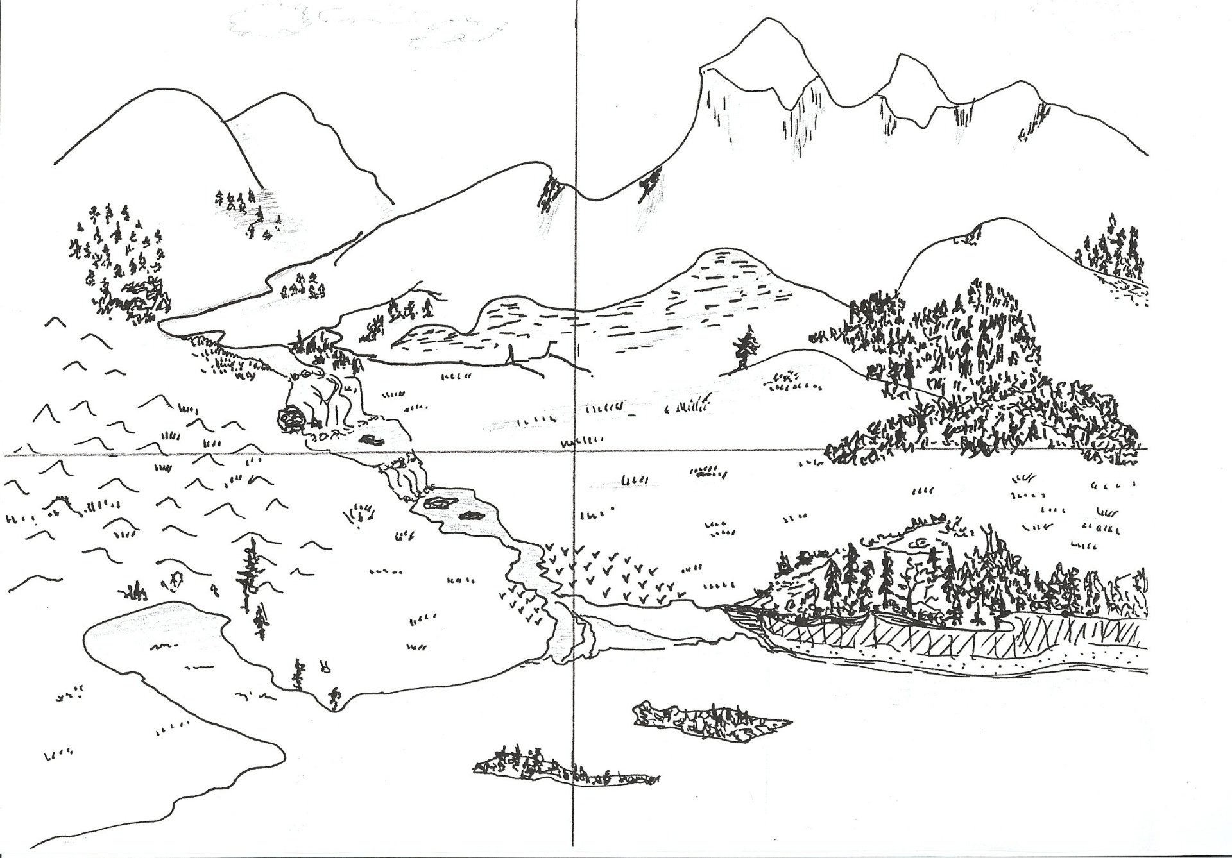

**Site 4**

**Site 3**

**Site 2**

**Site 1**

Green Cities

Transfer Task Potential Sites

Appendix 3

**Site 1**

This mountain valley will be the perfect place for your new city. Residents can escape the summer heat and will enjoy the beautiful mountain landscape. Rivers and a waterfall might be put to work to make electricity, and sportsmen will enjoy fishing and hunting. Flooding in the valleys and lowlands can be a problem occasionally, especially after storms and in the spring when the snow melts in the mountains.

Elevation: 700-1800 ft

Average Temperatures:

Summer 55˚-80˚ F

Winter 20˚-50˚ F

* Soils: Rocky with erosion along streams
* Land features: Steep hillsides with a narrow river valley and a flat area at the base of the hills with good cropland
* Water features: Three fast-moving rivers come together before a waterfall. Stream flows are heavy after storms and in spring when snow melts in the hills.
* Vegetation: Heavily forested at lower elevations and a natural meadow near the streams
* Animal life: Abundant fish, deer and other small game

**Site 2**

If you choose this site, your city will be high above all the rest. The scenery is beautiful, and the mountain climate makes skiing and other winter sports possible. Hunting is also a possibility. The benefits of this area will be worth the expense of building roads and transporting building materials. In the mountains, mineral deposits have already been discovered - including silver and lead - and there may be more!

Elevation: 1000-5000 ft.

Average Temperatures:

Summer 30˚-74˚ F

Winter 10˚-35˚ F

* Soils: Rocky, including granite and shale. Deposits of coal, small deposits of silver and lead.
* Water features: A few small mountain streams
* Vegetation: Heavily forested at lower elevations,
* Animal life: Deer, elk, bears and other game animals; a few sightings of mountain lions in recent years.

Green Cities

Transfer Task Potential Sites

Appendix 3

**Site 3**

Stay connected with the rest of the world by building a harbor city on this site. Residents will enjoy the mild climate in winter. Building and water travel in this area will be easy. It will be easy to plan around the fact that low-lying coastal areas can sometimes experience damage from wind, rain and storm surges from coastal storms.

Elevation: Sea level - 700 ft

Average Temperatures:

Summer 55˚-85˚ F

Winter 28˚-65˚ F

* Soils: Clay deposits and sandy soils with rocky base
* Land features: Low hills with some flat meadowland in eastern portion. Marshy area near the coast.
* Water features: River with small islands. Tide lands at mouth of river. Deep water harbor.
* Vegetation: Hardwood trees and shrubs. Marsh grass in low areas.
* Animal life: Some small animals, fresh water fish in rivers, saltwater fish along coast.

**Site 4**

Residents will enjoy the options created by the varied environments. Offshore islands, beautiful wooded areas and natural meadows contrast with the marshland. Perched on the cliffs, your city will be protected from coastal storms. Mosquitoes will only be a passing summer problem.

Elevation: Sea level – 1000 ft

Average Temperatures:

Summer 55˚-85˚ F

Winter 28˚-63˚ F

* Soils: Sandy soils with clay in marshy areas
* Land features: Mostly flat coastal plain with gentle hills in the interior. Erosion has caused a steep cliff along part of the coastline. Two small islands off shore.
* Water features: No rivers. Shallow water between coast and islands.
* Vegetation: Woodland covers about half the land area and both islands. Marshy land near the river. Some natural meadow.
* Animal life: Muskrats in the marsh. Deer, rabbits and small game.

Green Cities

Transfer Task Potential Sites

Appendix 3

**NOTES:**

Green Cities

Transfer Task

Student Rubric

| **Scoring Category**  **This exhibit provides evidence that …** | **Score Point 3** | **Score Point 2** | **Score Point 1** |
| --- | --- | --- | --- |
| I can read maps, charts and geography texts to get the information I need.   * Maps, Charts, Text | I can read geographic sources to get information. | I can read two kinds of geographic sources to find information. | I can read one geographic source to find information. |
| I can identify natural features of a site and tell how people could use them OR how people might have to change them in order to live in a place. | I can identify at least two natural features and their effects on the lives of people in a place. | I can identify one natural feature and its effects on the lives of people in a place. | I can identify at least one natural feature but cannot relate it to effects on the lives of people. |
| I can identify human or cultural characteristics of a site and explain how they affect a landscape. | I can identify at least two human or cultural characteristics and explain how they affect the landscape of the place. | I can identify at least one human or cultural characteristic and explain how it affect the landscape of the place. | I can identify at least one human or cultural characteristics but cannot explain its effect on the landscape of the place. |
| I can identify ways the geographic situation of a place (its location in relation to other places) might affect the lives of people in a place. | I can identify two ways the geographic situation of a place might affect the lives of people in a place. | I can identify one way the geographic situation of a place might affect the lives of people in a place. | I cannot identify or explain how the geographic situation of a place might affect the lives of people in a place. |
| I understand and apply geographic terms and concepts related to places.   * Site, Landscape, Physical and Human Characteristics, Situation, Environment | I always use geographic terms and concepts correctly. | I sometimes use geographic terms and concepts correctly. | I misused or left out two or more of the key terms or geographic concepts. |
| I represented geographic ideas and information about place through graphics. | I used map elements (TODAL) and mapping tools to construct a map or graphic to represent my ideas. Included clear labels and a legend or key. | I used labels and map elements and tools to construct a map, although some are left out or unclear. | I used a map or graphic to represent ideas, but most key elements are missing or used incorrectly. |
| I included specific features in my city design to match physical and human characteristics of the site. | I included 3 specific features in my city (buildings or facilities) designed to match physical and human characteristics of the site. | I included 2 specific features in my city design to match physical and human characteristics of the site. | I included at least one specific feature in my city design to match physical and human characteristics of the site. |