International Festival
Cultural Regions of the World Research Project

Curriculum Area: Seventh Grade Social Studies
Appropriate Group Size: Small Groups of 2 or 3
Time Expected to Complete Project: 10 class work days + out of class work if needed
Students will:
- Identify common elements of cultures from around the world, including Social Organizations, Customs and Traditions, Languages, Arts and Literature, Religion, Forms of Government, Economic Systems, Food and Clothing, and Music and Dance.
- Describe each element of culture, giving specific examples of each
- Apply their knowledge of cultural elements to create a group research project, which illustrates the elements of culture from a specific country of the world. In addition, they will compare these elements of culture to their own through written articles, illustrations, charts, graphs, artifacts, and visual arts.
Materials and Resources Needed:
- Various social studies textbooks, books and magazines such as National Geographic
- School Media Center for researching country information
- Internet access for information on cultures (See additional websites below)
- Construction paper, markers, colored pencils, scissors, glue, tape, etc…
- Trifold presentation boards (teacher supplied if needed)

Dear student,
During the next four weeks, you will be part of a team, researching the many elements of culture from a country in the Western Hemisphere. You will be responsible for deciding how to split up the work within the group. There are 8 elements, so you are responsible for four (three if you are a group of 3). You must put your name on all work that you complete. Below are examples and ideas to guide you in your research. You are not limited to these examples. BE CREATIVE! Don't just write about it. Create models, paintings, artifacts, posters, comparison charts, graphs, etc… Remember that your group will set up a display of all your research. You can have samples of food from your country, and you can be wearing clothing, which resembles the clothing typical of your country.

Elements of Culture
- Customs and Traditions
- Write a one-page description of the customs and traditions within your country.
- Make a poster to compare the customs and traditions of your assigned country to those of your own family.
- Create a short video, which shows people acting out customs and traditions in your assigned country.

- Languages
- Create a graph, which shows the percentages of the people in your assigned country who speak certain languages.
- Draw a poster showing how languages are sometimes barriers to understanding one another.
- Write a letter to the government of your country with suggestions for dealing with language barriers between people in that country.

- Arts and Literature
- Print out a large image from one of the Art Databases on the Internet, and then write a paragraph explaining what the art shows about the culture at that time in history.
- Research an artist from your assigned country, and write a short report about his/her artistic work. Include images of that artist's work.
- Write a book review of a story from your assigned country.
- Create a story based on a historic event in your assigned country.

- Religion
- Create a model of a shrine or temple from your assigned country and add a poster, which illustrates religious beliefs.
- Create replicas or use images of religious icons and write a paragraph explaining the significance of these icons and discuss basic elements of the religion and how it has spread throughout history.

- Forms of Government
- Write a report describing the type of government in your assigned country.
- Create a poster showing the different branches of government and offices held.
- Compare the government today to that of 200 years ago. Are they the same? How are they different?

- Economic Systems
- Explain how the economy in your assigned country compares with that of the United States. Traditional, Free Market, and Command Economies are three to use in a comparison.
- What are the major imports and exports of your country? Find an image of a market place in your country and write a short paragraph about what is happening in the image (Based on Economic facts within your assigned country)

- Food and Clothing
- Research information about typical foods from your assigned country. For example, in China, stir-fry was created out of necessity. Due to a lack of trees in the area, local people needed to chop their food into small pieces that would cook quickly and use less "fuel".
- Compare types of clothing worn by different classes of people. The Gentry, or upper class in China wore clothes that were very different from people in lower classes.
- Describe differences between upper classes and lower classes, or between people of different occupations.

- Music and Dance
- Create a computer presentation with music samples from the past and present in your assigned country then, describe your thoughts on this music and why it is appealing to the people.
- Create a model of traditional instruments or people dancing and write a brief report describing the model.
- Draw a picture of people engaged in dancing. Describe what is going on. Are they dancing for a wedding, religious ceremony, funeral?

Examples of Presentation Boards

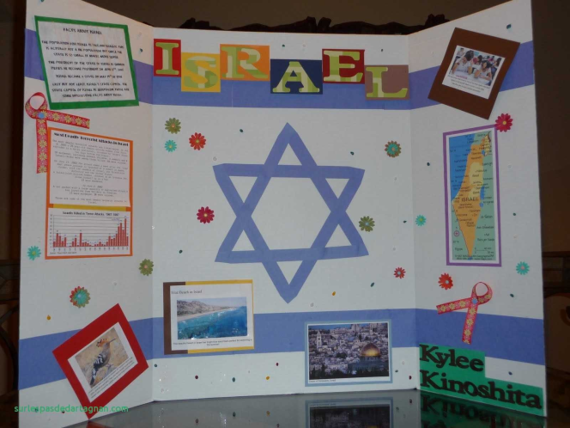
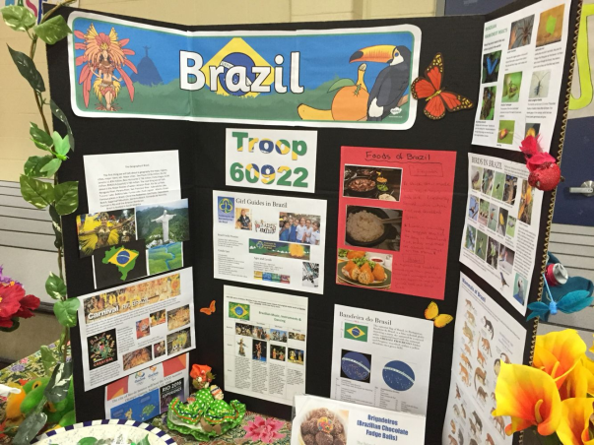

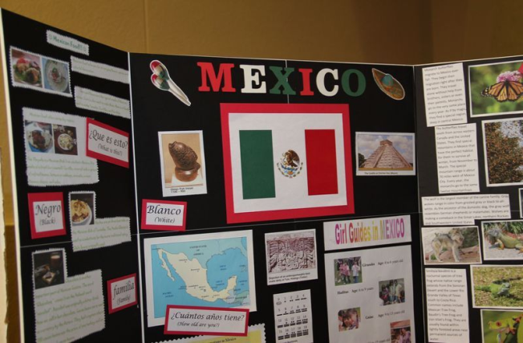
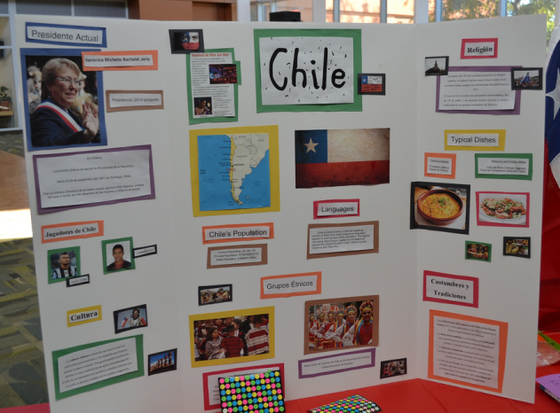

Checkpoint #1 Country Research
(Complete and get signed by October 29th)
Country Name________________________________________________
Element of Culture | Research Notes | Source(s) (Website Title, Book, Magazine)
Customs and Traditions
Languages
Arts & Literature
Religion
Forms of Government
Economic Systems
Food & Clothing
Music & Dance

Check Point #1 | Teacher Signature: | Date:

Check Point #2 Presentation Products
(Complete and get signed by October 31st)

Element of Culture | Group Member Responsible for Product | Description of Product to be created
Customs and Traditions
Languages
Arts & Literature
Religion
Forms of Government
Economic Systems
Food & Clothing
Music & Dance

Check Point #2 | Teacher Signature: | Date:

Checkpoint #3 Presentation Board Design
Sketch your plan for your Trifold Presentation Board and any other parts of your display
(Complete and get signed by November 2nd)

Check Point #3 | Teacher Signature: | Date:

Peer Evaluation Form for Group Work

Your name ____________________________________________________

Write the name of each of your group members in a separate column. For each person, indicate the extent to which you agree with the statement on the left, using a scale of 1-4 (1=strongly disagree; 2=disagree; 3=agree; 4=strongly agree). Total the numbers in each column.

Evaluation Criteria | Group member: | Group member:
Completes group assignments on time.

Prepares work in a quality manner.

Demonstrates a cooperative and supportive attitude.

Contributes significantly to the success of the project.

I would work with this person again.
TOTALS

